MiniProject Week-6

**//TaskList**

import React from "react"; import Task from "./Task";

function TaskList({ tasks, removeTask, selectTask }) { return (

<div>

<h2>Task List</h2>

{tasks.map((task) => (

<Task

key={task.id} task={task} removeTask={removeTask} selectTask={selectTask}

/>

))}

</div>

);

}

export default TaskList;

**//Task.js**

import React from "react";

function Task({ task, removeTask, selectTask }) { const handleRemove = () => {

removeTask(task.id);

};

const handleSelect = () => { selectTask(task);

};

return (

<div>

<h3>{task.title}</h3>

<p>{task.description}</p>

<button onClick={handleRemove}>Delete</button>

<button onClick={handleSelect}>Edit</button>

</div>

);

}

export default Task;

**//AddForm.js**

import React, { useState } from "react";

function AddForm({ addTask }) {

const [title, setTitle] = useState("");

const [description, setDescription] = useState("");

const handleSubmit = (e) => { e.preventDefault();

const task = {

id: Math.floor(Math.random() * 10000), title,

description,

};

addTask(task); setTitle(""); setDescription("");

};

return (

<div>

<h2>Add Task</h2>

<form onSubmit={handleSubmit}>

<label> Title:

<input

type="text" value={title}

onChange={(e) => setTitle(e.target.value)}

/>

</label>

<br />

<label> Description:

<textarea value={description}

onChange={(e) => setDescription(e.target.value)}

/>

</label>

<br />

<button type="submit">Add</button>

</form>

</div>

);

}

export default AddForm;

**//UpdateTask**

import React, { useState, useEffect } from "react";

function UpdateTask({ selectedTask, updateTask, setSelectedTask }) { const [title, setTitle] = useState("");

const [description, setDescription] = useState(""); useEffect(() => {

setTitle(selectedTask.title); setDescription(selectedTask.description);

}, [selectedTask]);

const handleSubmit = (e) => { e.preventDefault();

const updatedTask = { id: selectedTask.id, title,

description,

};

updateTask(selectedTask.id, updatedTask); setSelectedTask(null);

};

return (

<div>

<h2>Update Task</h2>

<form onSubmit={handleSubmit}>

<label> Title:

<input type="text" value={title}

onChange={(e) => setTitle(e.target.value)}

/>

</label>

<br />

<label> Description:

<textarea value={description}

onChange={(e) => setDescription(e.target.value)}

/>

</label>

<br />

<button type="submit">Update</button>

<button onClick={() => setSelectedTask(null)}>Cancel</button>

</form>

</div>

);

}

export default UpdateTask;

**//App.js**

import React, { useState } from "react"; import TaskList from "./components/TaskList"; import AddForm from "./components/AddForm";

import UpdateTask from "./components/UpdateTask"; function App() {

const [tasks, setTasks] = useState([]);

const [selectedTask, setSelectedTask] = useState(null); const addTask = (task) => {

setTasks([...tasks, task]);

};

const removeTask = (id) => { setTasks(tasks.filter((task) => task.id !== id));

};

const selectTask = (task) => { setSelectedTask(task);

};

const updateTask = (id, updatedTask) => {

setTasks(tasks.map((task) => (task.id === id ? updatedTask : task))); setSelectedTask(null);

};

return (

<div>

<h1>Task Manager</h1>

<TaskList tasks={tasks} removeTask={removeTask} selectTask={selectTask} />

<AddForm addTask={addTask} />

{selectedTask && (

<UpdateTask selectedTask={selectedTask} updateTask={updateTask} setSelectedTask={setSelectedTask}

/>

)}

</div>

);

}

export default App;

**Output:**

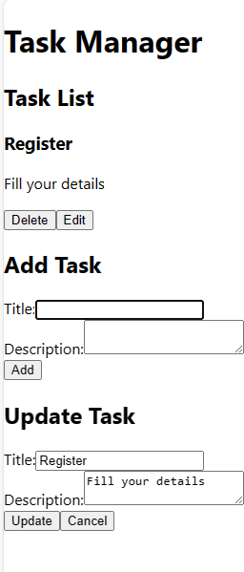

**Github:**

**https://github.com/717821L242/Task-Manager**